Pedro Henrique Nazário da Silva

Gini Coefficient

What is the Gini coefficient in your country?
At Brazil, we have a big problem of income distribution, so our country don't have the bests gini coefficient in the world, the most part of people in Brazil are poor and the less part is very rich, the people here are divided by social class, we have 5 levels of social class in Brazil: A,B,C,D and E. Where the most part of population are concentrated in C and D econom levels.

Is there a country that has a more fair income distribution?
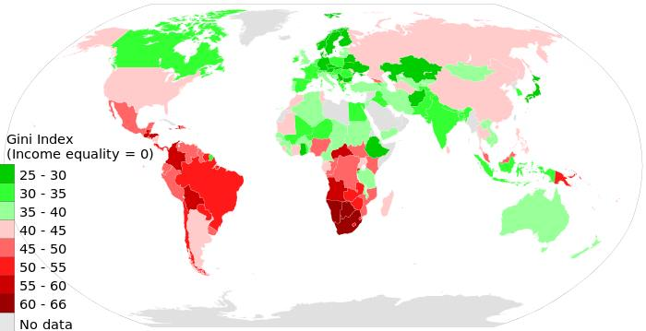
As you can see here, on this image, the countries that have a green color, have a most fair income distribution, the most part of this countries, you can find at Europe, North America and Oceania.

Which country do you think is more fair?

In my opinion, countries that make part of G7 are more fair, because they are most industrialized and economically developed in the world, so, they have more conditions to create a society most fair.

Imperialism

Did you learn anything from these? If so, what?

Imperialism has contributed in a very negative way for the countries that were colonized, because the way that imperialism acted, was not to help the parents what has been achieved, but rather, to acquire the resources that these countries had, as raw material, market expansion and slaves. So in my opinion, imperialism contributed only to create an inequality between countries, because if you notice, the countries that went through a regime imperialism today are poor countries. Brazil had a system of imperialism imposed by Portugal and although today is an emerging power still on fairly because of imperialism.

Which side should India should have been on during World War II?

In my opinion, India did the right choose, that was support your allies to gain their independence from England. England was very weak after the second war, so it can't keep your domain over India.

